Power BI Project Documentation: BMW Sales Analysis
Author: Scholarytics (Riam Arbab – Walaa Hasan – Hourya Ayman – Ahmed Mamdouh – Michael Mark – Hamza Elkhateeb) Date Created: October 19, 2025 Last Updated: November 17, 2025 Version: 1.0

1. Project Overview

1.1. Purpose & Business Goal
The primary objective of this project is to deliver a comprehensive, interactive analysis of BMW sales performance across 11 key models from 2010 to 2024.
This report moves beyond static spreadsheets to provide a dynamic analytical tool. It empowers stakeholders to explore complex sales data, identify critical market trends, analyze regional performance, and understand customer preferences in real-time.
The core business questions this report answers are:
- What is the overall sales performance (Volume and Price) over the last 14 years?
- Which regions are driving the most growth, and which are underperforming?
- What are the sales trends for specific models (e.g., 3 Series vs. M3)?
- How do customer preferences (Fuel Type, Transmission, Color) impact sales volume?

1.2. Stakeholders & Audience
- Primary Stakeholders: Sales Directors, Marketing Leadership, Regional Managers
- Target Audience: Business Analysts, Regional Sales Managers, Product Managers
- Access Level: View-only (via Power BI App/Web)

1.3. Scope
- In-Scope:
  - Data: Analysis of 11 distinct BMW models.
  - Timeframe: 14-year period from 2010 to 2024.
  - Phases: Complete end-to-end project execution, including:
    - Data Cleaning & Transformation (ETL)
    - Data Modeling & Relationship Building
    - DAX Measure Creation
    - Advanced Report & Visual Development
- Out-of-Scope:
  - Sales forecasting and predictive analytics.
  - Analysis of data beyond the provided BMW Sales.xlsx.

2. Data Model & Transformation
A significant portion of the project was dedicated to building a robust and clean data model, which is the foundation of this entire report.

2.1. Data Sources
- Source 1: Main Sales Data
  - Type: Excel File
  - File: BMW Sales.xlsx
  - Connection Mode: Import
  - Description: This core file contains all transactional sales data, including model, year, region, price, and other attributes.
- Source 2: Custom Image Link Table
  - Type: Manually Created Table (within Power BI / Excel)
  - Connection Mode: Import
  - Description: A key project enhancement involved the creation of a custom dimension table to store high-resolution image URLs for each of the 11 car models. This table was essential for enabling the innovative car image slicer on the "Details" page.

2.2. Data Cleaning & Transformation (Power Query)
Substantial effort was invested in the data transformation phase to ensure accuracy and usability. Raw data was meticulously processed in Power Query, including:
- Verifying data types for all columns (e.g., Price_USD as Currency, Year as Whole Number).
- Ensuring consistency in categorical data (e.g., Region, Model).
- Handling any potential null or blank values to prevent report errors. This foundational work was critical for building a reliable and trustworthy analysis.

2.3. Data Model

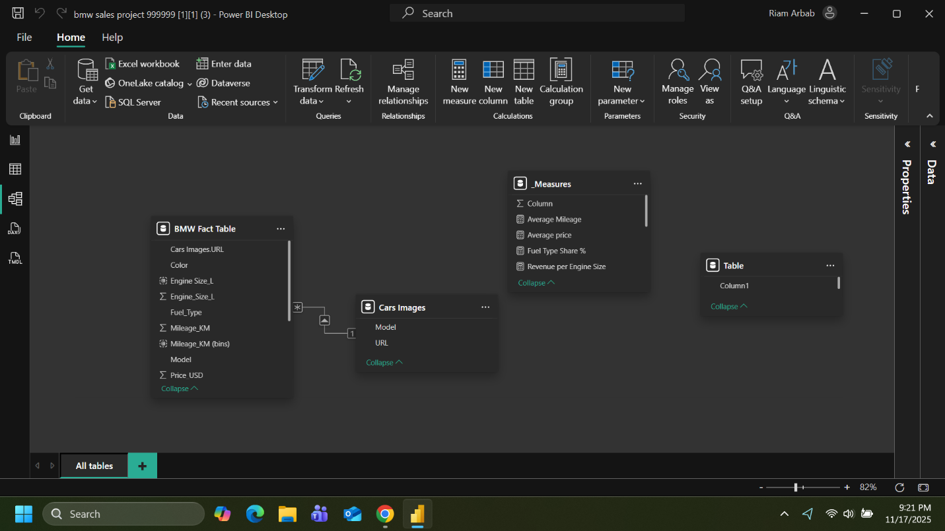
The data model consists of the primary BMW_Car_Sales fact table, which is linked to the custom-built Dim_Car_Images dimension table.
- Relationship: BMW_Car_Sales[Model] (Many-to-One) -> Dim_Car_Images[Model]

2.4. Key DAX Measures
A suite of 10 critical DAX measures was developed to enable deep analysis, moving beyond simple sums to complex performance indicators:
- Total Sales Volume
  - Formula: SUM('BMW_Car_Sales'[Sales_Volume])
  - Purpose: Shows overall demand across all markets.
- Total Revenue
  - Formula: SUM('BMW_Car_Sales'[Price_USD] * 'BMW_Car_Sales'[Sales_Volume])
  - Purpose: Gives the overall revenue contribution per region/year.
- Average Selling Price (ASP)
  - Formula: [Total Revenue] / [Total Sales Volume]
  - Purpose: Measures revenue per unit, vital for profitability analysis.
- Sales by Region (%)
  - Formula: (Sales_Volume per Region ÷ Total Sales Volume) * 100
  - Purpose: Helps identify the strongest and weakest global markets.
- Sales Growth by Year
  - Formula: (Sales_Volume(Current Year) – Sales_Volume(Previous Year)) ÷ Sales_Volume(Previous Year)
  - Purpose: Tracks demand trends and year-over-year performance changes.
- Fuel Type Market Share
  - Formula: (Sales_Volume per Fuel_Type ÷ Total Sales Volume) * 100
  - Purpose: Shows the adoption rate of Electric vs. Hybrid vs. Petrol models.
- Transmission Preference
  - Formula: (Sales_Volume per Transmission Type ÷ Total Sales Volume) * 100
  - Purpose: Provides the sales split between Manual and Automatic transmissions.
- Average Mileage at Sale
  - Formula: AVERAGE('BMW_Car_Sales'[Mileage_KM])
  - Purpose: Helps understand customer behavior and vehicle usage lifespan.
- Sales Classification Distribution
  - Formula: COUNT('BMW_Car_Sales'[Sales_Classification]) by category (Low, Medium, High).
  - Purpose: Helps see performance distribution across models based on classification.
- Revenue per Engine Size
  - Formula: [Total Revenue] grouped by Engine_Size_L.
  - Purpose: Compares revenue contribution by engine capacity (e.g., 2.4L vs 4.0L).

3. Report & Dashboard Design
The report is a 3-page, dark-themed application designed to provide a seamless user experience, from a high-level overview to a granular deep-dive.

3.1. Report Pages
- Page 1: Introduction
  - Purpose: Serves as a professional landing page and executive summary. It clearly outlines the report's objective and scope, setting the context for the analysis.
- Page 2: Sales Overview
Purpose: A high-level executive dashboard providing an "at-a-glance" understanding of performance. Crucially, this page focuses on identifying the most popular and highest-selling model within each continent/region.

  - Key Visuals:
    - KPI Cards: Total Sales, Total Price, Sales Volume, Total Mileage.
    - Charts: Sales by Year (Line Chart), Sales by Region (Map).
    - Slicers: Year, Region, Model, Fuel Type, Transmission.
- Page 3: Details
  - Purpose: This page provides a granular, deep-dive analysis into customer preferences and specific model attributes.
  - Key Visuals:
    - Custom Image Slicer: The centerpiece of this page. This innovative slicer allows stakeholders to visually filter the entire report by clicking on a high-resolution image of the car model.
    - Charts: Sales by Color, Sales by Fuel Type, Sales by Transmission.
    - Detailed Table: A matrix showing all raw data for granular inspection.

4. Data Refresh & Security

4.1. Data Refresh
- Refresh Type: Scheduled Refresh.
- Gateway: (Not required if Excel file is hosted in OneDrive/SharePoint).
- Frequency: Daily at 5:00 AM UTC (Recommended).

4.2. Row-Level Security (RLS)
- Is RLS Used? No. This report is intended for a global audience with full data visibility.

4.3. Deployment
- Method: Published as a Power BI App to ensure a clean, simple interface for end-users and to manage permissions effectively.

